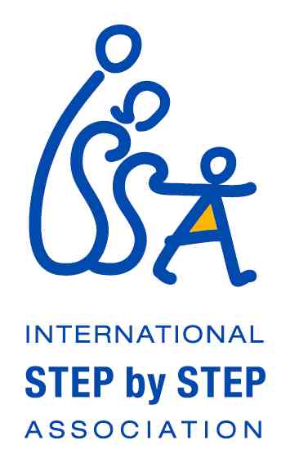

Call for Expressions of Interest

The Open Society Foundation’s Roma ‘Kopaçi’ initiatives at the Early Childhood Programme (ECP) and the International Step by Step Association (ISSA), in cooperation with ISSA’s members, plan to launch a joint initiative aiming to empower Roma and non-Roma Early Childhood Development (ECD) professionals and para-professionals working with Romani communities, offering them opportunities for professional development, study visits and international networking across the early childhood development sector.

As part of this initiative, OSF’s Roma ‘Kopaçi’ initiatives at the ECP and ISSA plan to launch a Roma Early Childhood Development Professionals’ Network during the forthcoming ISSA/DECET Conference in Opatija, Croatia, 14th – 17th October 2012. This year’s conference is on a topic closely related to professional development and learning communities: Co-constructing Professional Learning: Pathways towards Quality, Equity and Respect for Diversity in ECEC. Please visit the conference website for further details:http://issa-decet2012.com.hr/.

OSF’s Roma ‘Kopaçi’ initiatives and ISSA invite interested professionals and para-professionals working in services aimed at young Romani children (birth to 8 years) and their families, to submit expressions of interest in joining the Conference and taking part in activities related to the launch of the Roma Early Childhood Development Professionals’ Network. In addition to benefitting from the professional development opportunities offered by the conference sessions themselves, those who attend will also be able to take part in sessions aimed at empowering professionals and para-professionals who work in a context of ethnic diversity, improving social justice, delivering anti-discrimination programmesand improving social cohesion. Participants will also be able to contribute with ideas on how the new Roma ECD Professionals’ Network may best serve the needs and aspirations of professional and para-professional network members – Roma and non-Roma professionals and para-professionals alike. Conference registration fee, travel, accommodation and daily maintenance costs will be supported by the OSF’s ECP Roma ‘Kopaçi’ initiatives.

Theschedule will be the following:

- Arrival in Zagreb on October 13, transfer to Opatija and welcome dinner
- Network Meeting on October 14
- Conference October 15-17 – including Network Launch Events on October 15 and optional sightseeing visit onOctober 17 in the afternoon
- Departure either on the afternoon of October 17 or during October 18 – transfer from Opatija and flight from Zagreb

We particularly welcome expressions of interest from Roma ECD professionals and para-professionals, especially Romani men, as they are under-represented in the early childhood sector as a whole.

With regards to criteria for eligibility, we would ask that applicants

- be a professional/para-professional working in services aimed at young Romani children (birth-8) and their families in Central Eastern Europe, South-Eastern Europe, CIS and MENA regions
- are qualified, experienced or work presently in early years services and provision in any oneor more of the following positions:
  - Teacher
  - Educator
  - Psychologist / School counselor
  - School mediator working in ECD (preschool, kindergarten, nursery, etc.)
  - Nursery nurse
  - Psycho-pedagogue/specialist working with children with special needs
  - Speech therapist (logoped)
  - Pedagogue
  - Community mediator working with parents to support their skills
  - Health mediator
  - Teaching assistant
  - Roma community worker
  - Roma community nursery nurse
- have a high competence in English language skills, to be able to sufficiently benefit from the conference and from training sessions in English
- be interested in becoming an active participant of the Roma ECD Professionals’ Network,as it is launched at the ISSA/DECET Conference

Kindly send your expression of interest to issa@issa.huby 3 August 2012, in which we ask you to include:
- brief information on your current/previous position, work, experience and qualifications in Early Childhood Development
- a short statement (maximum 150 words) telling us why you would like to participate in the October events in Opatija, Croatia
- your contact information (e-mail, mobile telephone number, Skype contact or other details)
- brief details of your nationality – so we may check if you need a visa for Croatia

We will inform the successful applicants by 15 August 2012.

For more information, please visit the ISSA web-site (www.issa.nl) or the OSF Early Childhood Programme web-site (http://www.soros.org/about/programs/early-childhood-program) or contacteizsak@issa.huand adrian.marsh@osf-eu.org.

